34. Draw the flowchart using Raptor; Write a shell script to find the largest of n numbers in a range. Accept the size of a range (N) and accept each number in the range. Use an editor to write your script Change its permission to run as a script. Run your script with these sets of input below. The output should be preceded by the text "The largest number in this range is '' First range 5, the numbers are 4, 56, 78, 34, 123 Second range 6, the numbers are 99, 33, 1, 15, 25, 33 Find Cyclomatic Complexity for a graph having number of edges as 20, number of nodes as 15 and number of predicate nodes in the flow graph as 4.

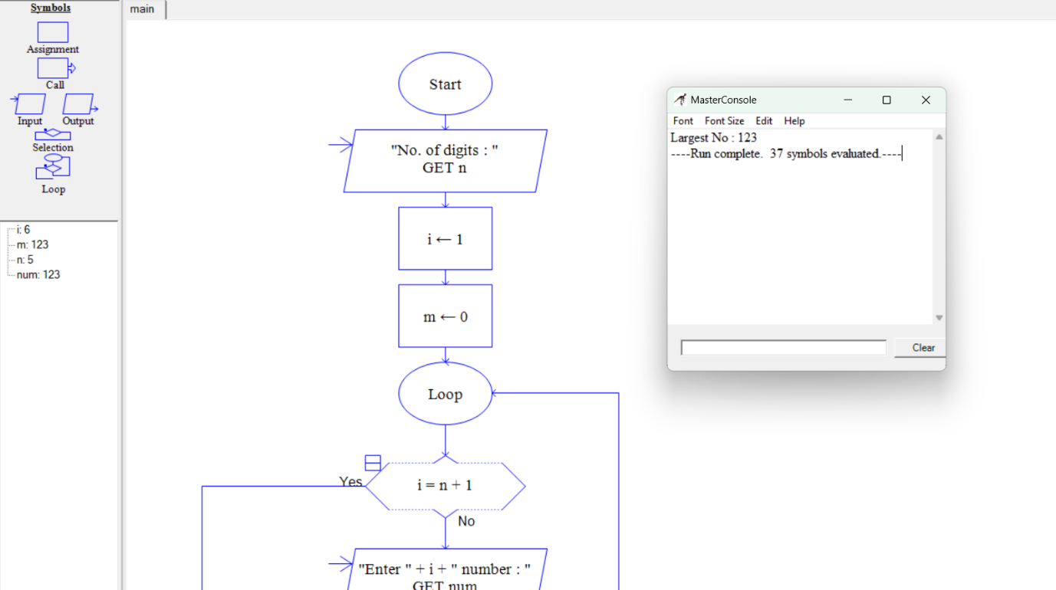35. Using Raptor- Draw and validate the flowchart to calculate Fibonacci Series which plays a big part in Western harmony and musical scales. Here are the facts: An octave on the piano consists of 13 notes. Eight are white keys and five are black keys. A scale is composed of eight notes, of which the third and fifth notes create the foundation of a basic chord. In a scale, the dominant note is the fifth note, which is also the eighth note of all 13 notes that make up the octave. Eight divided by 13 equals 0.61538 the approximate Golden Ratio. Using Raptor, draw and validate the flowchart.

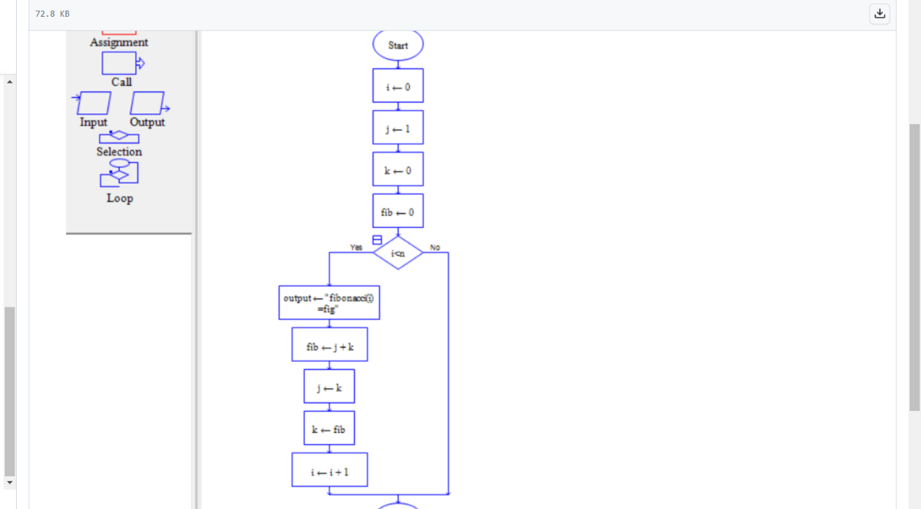36. Draw the flowchart using Raptor; given a number n find the smallest number evenly divisible by each number 1 to n.

Examples:

Input: n = 4

Output: 12

Explanation: 12 is the smallest numbers divisible by all numbers from 1 to 4

Input: n = 10

Output: 2520

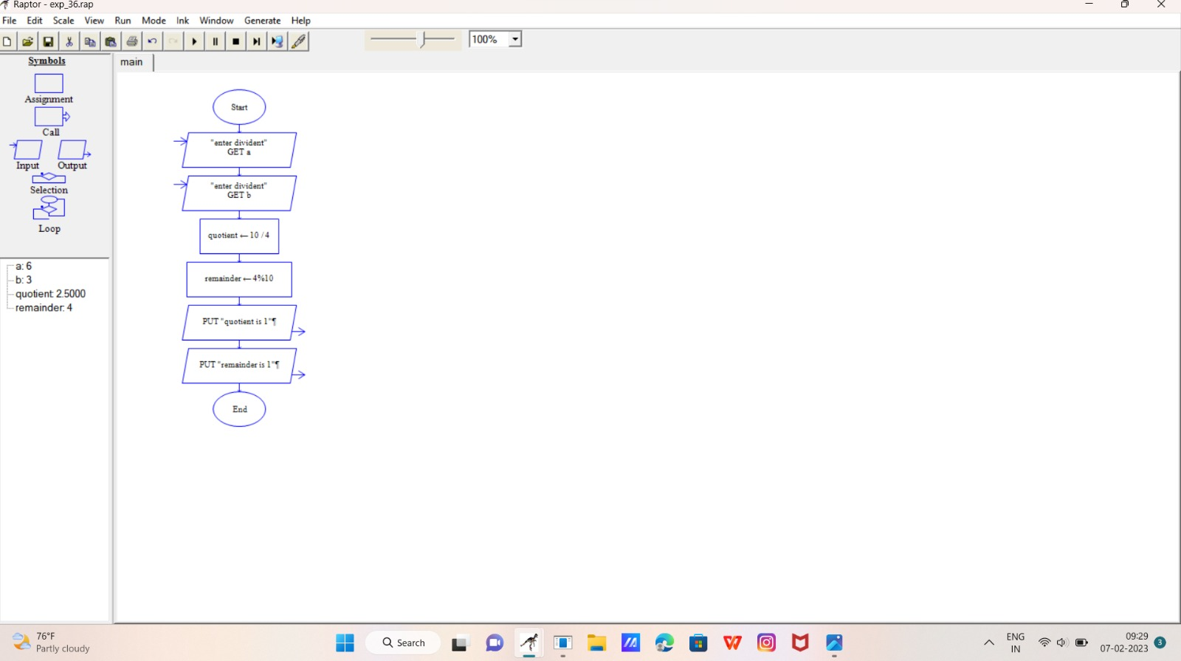40. Construct a flowchart using raptor and Check whether a string is palindrome or not a palindrome is a word, number, phrase, or other sequence of symbols that reads the same backwards as forwards, such as the words madam or race car

